The Faculty of Philosophy, University of Sarajevo, are pleased to announce that a Japanese language course, taught by a native Japanese speaker and a local teacher, will be offered to the citizens of Bosnia and Herzegovina in the 2025/2026 academic year.  
  
**Duration and Dates**

**\*The schedules may be subject to change.**

October 2025 – June 2026 (Final test will be held outside of the schedule)  
1st semester: 6 October 2025 – 31 January 2026  
2nd semester: 23 February 2026 - 12 June 2026  
  
**Groups and schedule**

**\*The schedules may be subject to change.**

Please see also Course Description below.

|  |  |  |  |  |
| --- | --- | --- | --- | --- |
| Monday | Tuesday | Wednesday | Thursday | Friday |
|  | 16:20-17:50 **Level 2** - Lamija Mršo |  |  |  |
| 18:00-19:30 **Level 3** - Nozomi Miyanoya | 18:00-19:30 **Level 1**- Lamija Mršo | 18:00-19:30 **Level 3** - Nozomi  Miyanoya | 18:00-19:30 **Level 2**- Nozomi  Miyanoya | 17:30-19:00 **Level 1** - Nozomi  Miyanoya |

-**Main Course**  
**Level 1 group (Entry level course)**  
Tuesdays 18:00–19:30, Fridays 17:30–19:00

**Level 2 group**Tuesdays 16:20–17:50, Thursdays 18:00–19:30  
  
**Level 3 group**Mondays 18:00–19:30, Wednesdays 18:00–19:30

** The course will be cancelled if there will be less than 5 applicants.

** If you are interested in upper levels than we provide, contact here: sarajevo.jplc@gmail.com

**Total number of hours (per group)**  
1st semester: 90 minutes x 30 sessions  
2nd semester: 90 minutes x 30 sessions  
  
**Place**

Faculty of Philosophy (Franje Račkog 1)**The lessons will be held in person at the faculty. However, online participation is available for people who live outside of Sarajevo via ZOOM. Please note that the activity will be limited than in-person-participation.**  
**Fee**   
**350 BAM** for two semesters.  
- Payment should be made to the faculty’s bank account by the first lesson. Payment instructions will be provided once you send the application.  
- Students are expected to pay for their own materials (textbooks).  
Note: It is NOT possible to divide tuition by semesters.  
  
**Languages of Instruction**

Miyanoya’s class: Japanese and English   
Mršo's class: Bosnian, Croatian and Serbian, Japanese  
(In Level 2 class and above, instruction will be mostly provided in Japanese.)  
  
**Certificate:** Certificates will be issued upon completion of the course (in September 2026).  
   
**Age limit**The course is designed for people older than 13 years old.

**Registration**  
1. Please apply from the application form [HERE](https://forms.gle/bQLg4BggZqehVJTTA) (<https://forms.gle/bQLg4BggZqehVJTTA>) no later than Sunday, 28 September 2025. The payment instructions will be provided on the screen once you send the form.  
2. Please attend the Orientation Day in the beginning of October 2025. There you will have a chance to obtain general information about the course from the lecturers, talk to them, and ask questions.  
  
**Course Description**  
•    The student must commit to take the course seriously.  
•    The certification will be issued to students who attended classes throughout the academic year (both 1st and 2nd semesters). Your score (A-E) evaluated by attendance/activity/test marks etc. will be included on the certificate.  
•    The student must check his/her email throughout the duration of the course.  
  
**Level 1 class**  
This class is aimed at those who have no or almost no knowledge of the Japanese language. The course is based on a comprehensive Japanese textbook ***GENKI-1***. By the end of the course, through learning basic speaking, listening, writing and reading skills, students will be able to: read and write Japanese basic letters: Hiragana and Katakana, as well as basic Kanji characters; engage in short spoken discourse about everyday topics; and use basic Japanese structures and expressions in a given context.  
   
**Level 2 class**  
This class is for those who have completed the ***GENKI-1*** textbook **Chapters 1–7**, or have equivalent knowledge of Japanese. It covers basic grammar and Kanji characters. By the end of the course, students will be able to engage in spoken discourse on everyday topics at a deeper level and in a wider context.  
   
**Level 3 class**  
This is the intermediate Japanese course, aimed for those who have completed the ***GENKI-1*** and ***GENKI-2*** textbook or have equivalent knowledge of Japanese (JLPT N5 level). In this course, the intermediate-level textbook ***Tobira*** will be used. The focus will shift primarily to written Japanese, and students will read, learn about, and discuss a variety of topics such as Japanese culture, society, and history. In addition, practical conversation practice based on specific functions will also be included. The course will cover kanji at the JLPT N3 level.

**Textbook information**  
Main course  
- Beginners Level “GENKI”  
<http://genki.japantimes.co.jp/about_en>  
- Intermediate Level “TOBIRA”  
<http://tobiraweb.9640.jp/>

**Contact information**  
**Email:** [**sarajevo.jplc@gmail.com**](mailto:sarajevo.jplc@gmail.com)

**Facebook:** [**https://www.facebook.com/JapanskiSarajevo**](https://www.facebook.com/JapanskiSarajevo)

**Events and activities**  
1. Japanese Calligraphy Contest  
Participants will learn basic calligraphy and create their work using real Japanese calligraphy tools. The best works will be awarded by the Faculty of Philosophy and the Embassy of Japan.

[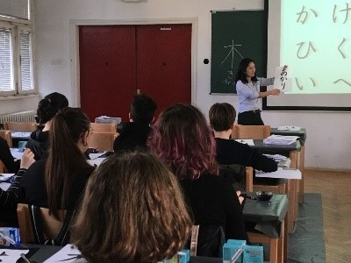](https://www.bosnia.emb-japan.go.jp/files/100079878.jpg)  [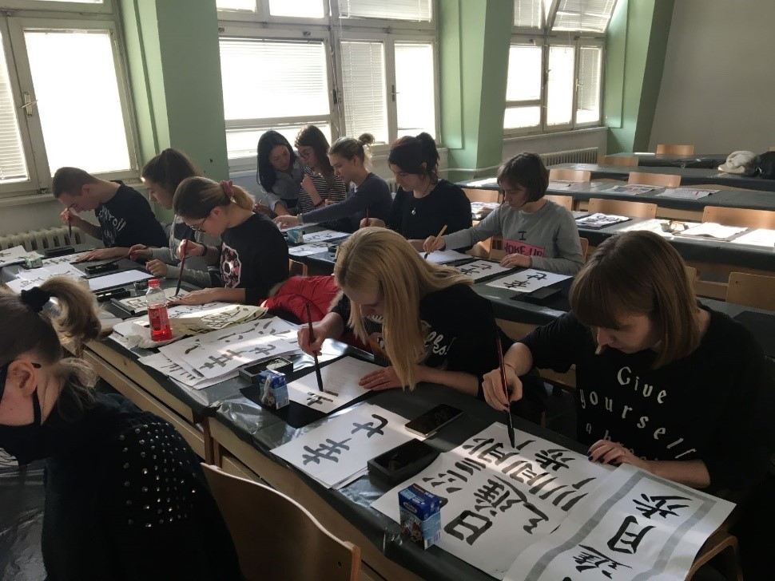](https://www.bosnia.emb-japan.go.jp/files/100079879.jpg)  [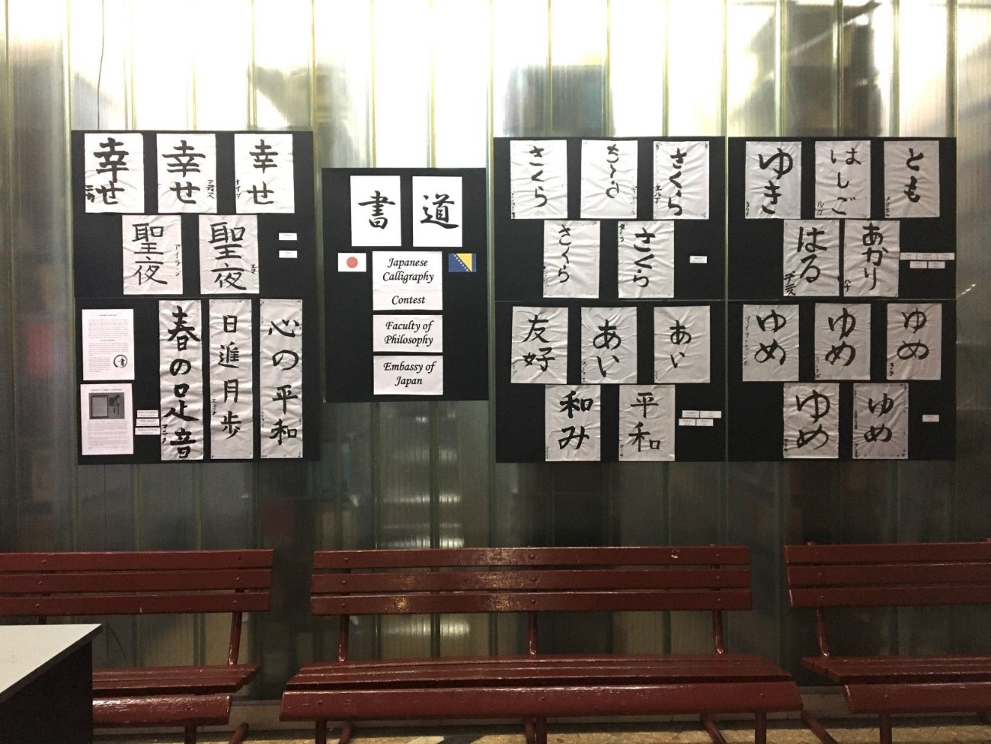](https://www.bosnia.emb-japan.go.jp/files/100079880.jpg)

2. Japanese Speech Contest  
Participants have a chance to voice their opinions to an audience in Japanese. It is divided into two sections: Beginner and Intermediate. The best speeches will be awarded by the Faculty of Philosophy and the Embassy of Japan.

[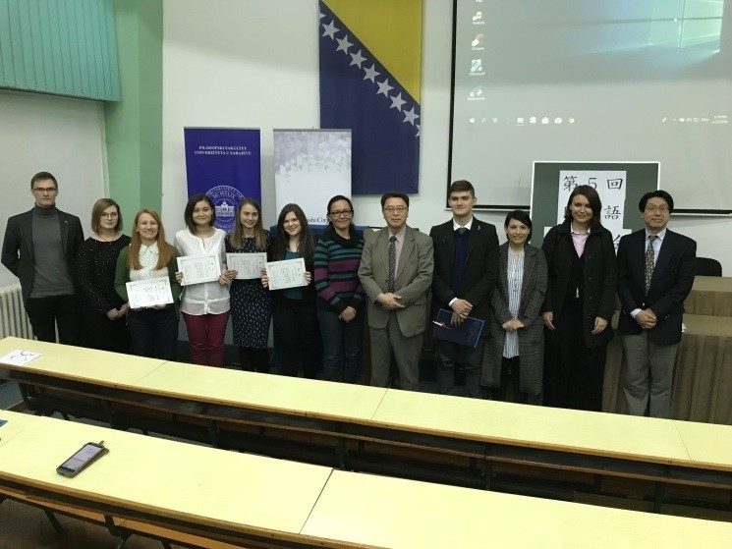](https://www.bosnia.emb-japan.go.jp/files/100079881.jpg)  [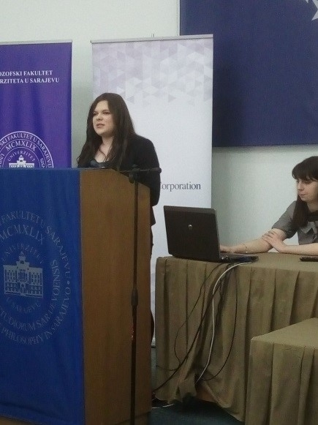](https://www.bosnia.emb-japan.go.jp/files/100079883.jpg)

3. Presentation Day  
This event is held annually at the end of the course (usually in June or beginning of July). Participants will make group presentations to introduce local culture to a Japanese audience in Japanese. Sometimes, students chose to get creative and hold demonstrations (e.g. baklava tasting), poetry reading or theatre play adaptations in Japanese, adjusted to their level with the help of their teacher or upperclassmen, and the teamwork of the group.

[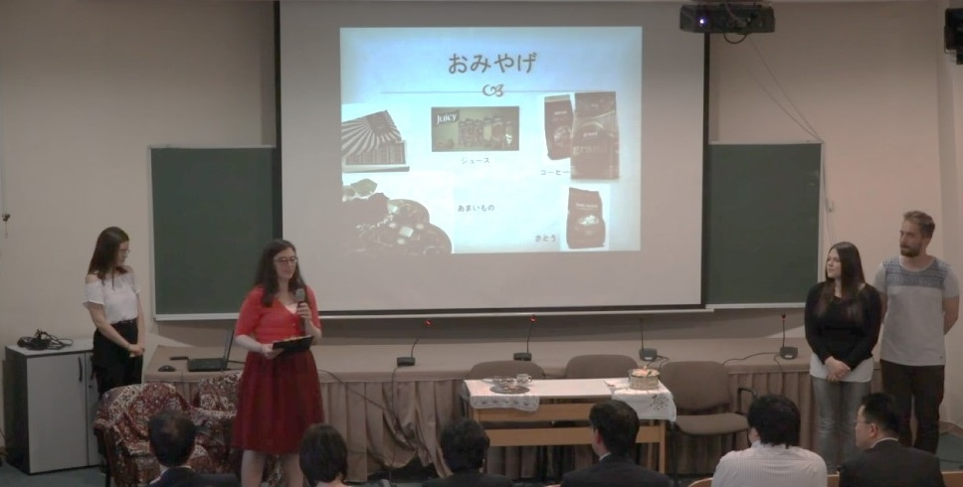](https://www.bosnia.emb-japan.go.jp/files/100079884.jpg)

4. Yukata Workshop  
The course provides more cultural workshops such as the Yukata (a summer variation of Kimono) workshop. We are open to any suggestions to expand on our activities!

[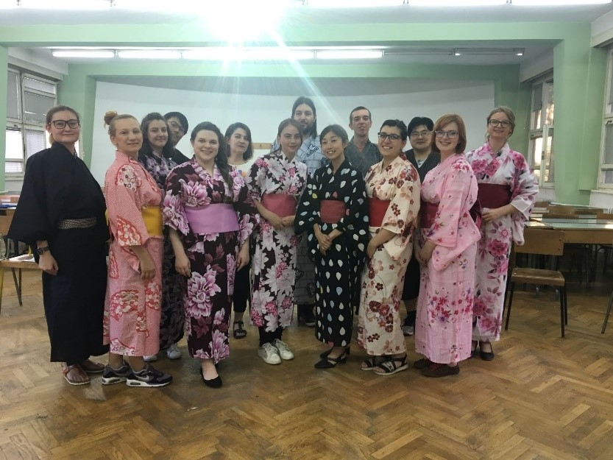](https://www.bosnia.emb-japan.go.jp/files/100079887.jpg)

5. Nihongo no Kai  
There is a monthly gathering over coffee, tea and snacks with Japanese people called „Nihongo no Kai“, where you have a chance to use your Japanese skills in a casual conversation with real Japanese, adjusted to your level! Sometimes, traditional Japanese food and snacks, as well as games, are showcased.   
  
***This course is provided with the support of the Embassy of Japan in Bosnia and Hercegovina and the Japan Foundation.***  
  
***Teacher introduction 先生の紹介  
[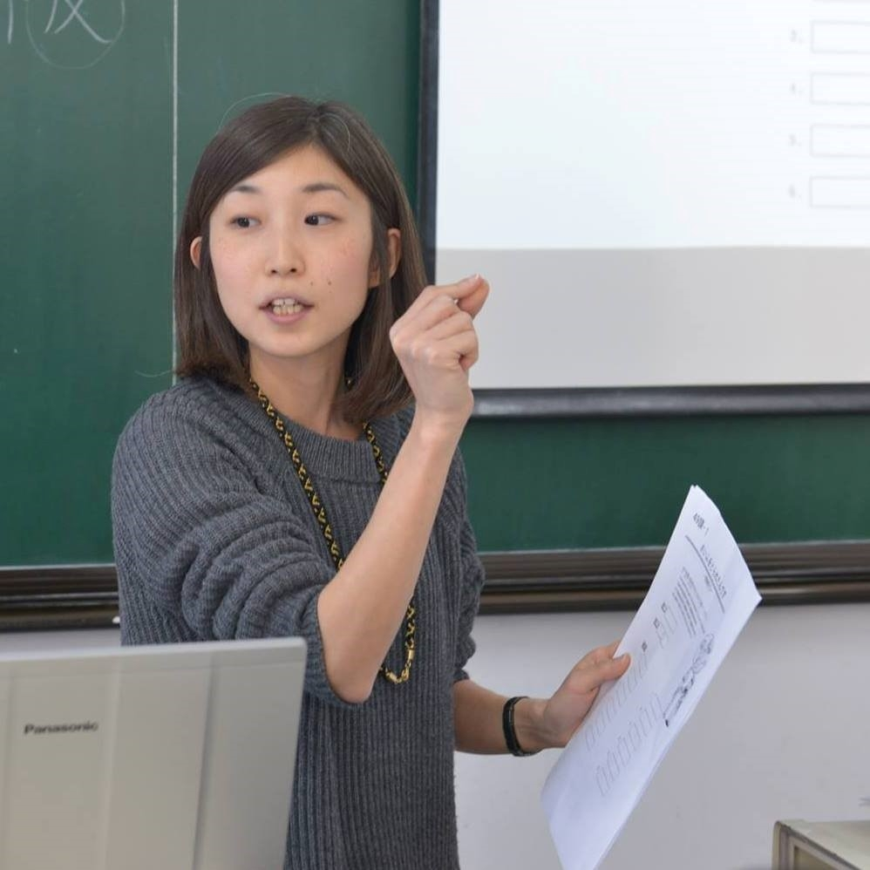](https://www.bosnia.emb-japan.go.jp/files/100079889.jpg)*  
MIYANOYA**　**Nozomi, MA / 宮野谷　希**  
Graduated from Tokyo University of Foreign Studies.  
Master of Applied Linguistics, specialized in Japanese language education.  
Research interest: Japanese semantics; onomatopoeia  
12-years-experience in total as a Japanese lecturer in Japan, China, Serbia and BiH.   
  
Dobar dan! I am Nozomi Miyanoya from Tokyo. I majored in Japanese education at Tokyo University of Foreign Studies, and Japanese Semantics is my profession.  
I can say I am an “otaku” of language who is always thinking about the meaning of words  :)  
I started my life in Balkans in 2012 when I started teaching Japanese at Belgrade University. I taught there for 3 years and came to Sarajevo in 2016. I fell in love with the culture, the life, and the people here through my career. :)  
   
Certainly, Japan is far away from here, but my wish is that the people in BiH get to feel Japan closer to your hearts through learning Japanese language and culture. The lessons are not only about words and grammars, but also full of insights of this fascinating language and culture. Besides the lessons, I am organizing Japan related events, such as on-line presentations and workshops, which helps you get in contact with Japanese people. I hope this course will be a good opportunity for the people in BiH and Japan to exchange their culture.  
  
Join us, and start exploring Japanese world!   
   
Vidimo se u oktobru!  
  
みなさん、こんにちは！宮野谷 希です。とうきょう しゅっしんです。とうきょうがいこくごだいがくで にほんごを せんこうして、2012ねんに ベオグラードに きました。ベオグラードだいがくで 3ねんかん にほんごを おしえて、2016ねんに サラエボに きました。ことばについて かんがえるのが だいすきです。いつも ことばの いみについて かんがえています…！ことばのオタクです。  
このコースが、ボスニアと にほんの いいこうりゅうの ばしょになると いいなとおもっています。  
そして、このコースでにほんごや にほんぶんかを べんきょうして、もっと にほんを ちかくに かんじてほしいと おもっています。  
いっしょに たのしいクラスを つくりましょう！  
10がつに みなさんに あえるのを たのしみにしています！  
   
**Assistant teacher**

**Lamija Mršo**  
  
Lamija is currently finalizing her major in Japanese Studies at the Faculty of Arts, University of Ljubljana, Slovenia, and she was also a fellow student of the Japanese language course in Sarajevo. She speaks English, German, Japanese, and Slovenian. Besides her major in Japanese Studies, her academic background includes the study of English Language and Literature and Bosnian, Serbian and Croatian Language at the Faculty of Philosophy, University of Sarajevo, Bosnia and Herzegovina, with experience in language teaching and translation. She currently works as an English and German language instructor.

Her approach focuses on conversation and vocabulary building, as well as building confidence in communication.